The 3rd ABU TV SONG FESTIVAL 2014

Participation Form

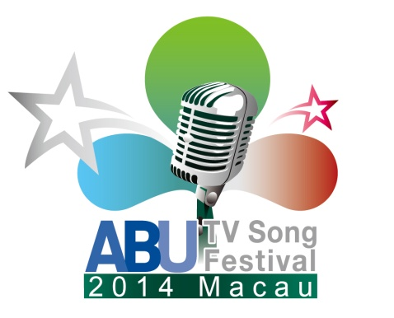

cc:

**Chairperson of ASC**

**Mr Kenny Kihyung Bae – KBS,Korea**

**E-mail:** [**kenny@kbs.co.kr**](mailto:kenny@kbs.co.kr)

**Host Organisation**

**Mr Lok Kong – TDM,Macau**

**E-mail:** [**LOKKONG@tdm.com.mo**](mailto:LOKKONG@tdm.com.mo)

To :

**Mr Tatsuhiro Beniko / Ms Hanizah Hamzah / Ms Lai Kai Yan**

ABU Programming Dept.

E-mail: [**beniko@abu.org.my**](mailto:beniko@abu.org.my) **/** [**hanizah@abu.org.my**](mailto:hanizah@abu.org.my) **/** [**yan@abu.org.my**](mailto:yan@abu.org.my)

Phone: +603-2282 2480

Fax: +603-2282 4606 **Japan** Malays**Fax : +603-2282 4606 Fax No: (60 3)2282 4606Phone : +603 2282 2480**

**ABU TV Song Festival Representative Producer**

Name :(Mr / Ms)__________________________________________________

Position/Dept :__________________________________________________________

Organisation : __________________________________________________________

Street Address :__________________________________________________________

Phone No :__________________________________________________________

Mobile :__________________________________________________________

Fax No :__________________________________________________________

E-mail :__________________________________________________________

**CONTACT PERSON (if not the ABU TV Song Festival Representative Producer)**

Name :(Mr / Ms)__________________________________________________

Position/Dept :__________________________________________________________

Organisation : __________________________________________________________

Street Address :__________________________________________________________

Phone No :__________________________________________________________

Mobile :__________________________________________________________

Fax No :__________________________________________________________

E-mail :__________________________________________________________

**Statement of Commitment (Signed by ABU TV Song Festival Representative Producer’s superior or other executive level director/manager)**

*Our organization is fully committed to participate in the 3rd ABU TV Song Festival and will provide our ABU TV Song Festival Representative Producer full support to fulfill his/her role.*

Name :_________________________________________________________

Position/Dept :__________________________________________________________

Signature :_________________________________________________________

Date :_________________________________________________________