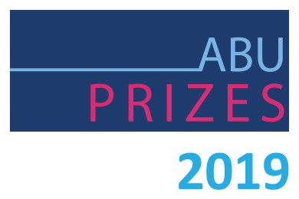

RADIO ON-AIR PERSONALITY AWARD SUPPLEMENTARY FORM

Radio On-Air Personality Award

This Award is for an on-air radio personality for work performed over a period of time.

The kind of ‘Personality’ considered can include: Radio DJ, program presenter, feature/documentary series presenter, interviewer, talkback host, sports commentator or regular specialist commentator, among others.

Although the nominee will be assessed on an audio excerpt provided, this Award is presented for a body of work, which should be described in detail in the Nomination Form addressing some or all of the following criteria:
- The exceptional quality of his/her work.
- A special or outstanding presentation style.
- Interaction with his/her audience on-air and/or off-air.
- Responses to his/her programs from audience members or broadcasting specialists.
- Audience ratings or similar formal or semi-formal feedback measures.
- Interaction with talent, interviewees etc in making his/her programs.
- What kind of excitement is generated amongst his/her audience.

Please use the space below to explain how your Entry qualifies for this Award.

In exceptional circumstances, the Award Judges will accept Nominations for a personality duo, if it can be demonstrated that: - They are a well-established pairing on their programs. - They appear together on a regular basis. - It is not possible to distinguish who has a major role in their one-air work. - The quality of their programs depends on the “chemistry” between them on-air.

