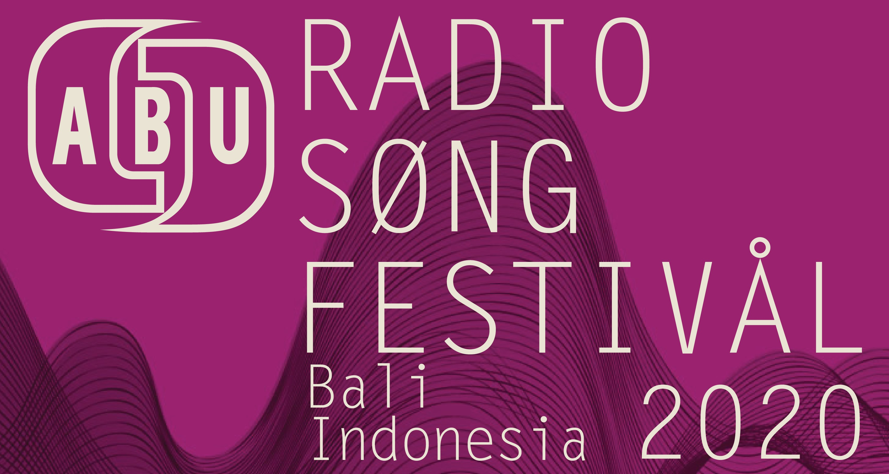
TERMS & CONDITIONS AND SINGER(S) ENTRY FORM
* Entry form to be filled by the singer(s)/ on behalf of the singer(s) by the particpating broadcasting organisations.

* Please return the filled entry form to olya@abu.org.my or nisa@abu.org.my by Friday, 17th April 2020.

Are you ready to bring your original music to the rest of the Asia-Pacific?

This year’s ABU Radio Song Festival will be held on 11th June 2020 in Bali, Indonesia and hosted by the Radio Republik Indonesia (RRI).

The ABU Radio Song Festival aims to showcase and recognize the diverse, young, unknown musical talents of nations within the ABU membership to international audience in a one-day concert. It will be great exposure to the singers, as well as bringing prestigious to the ABU Members that support their endeavor in the Radio Song Festival.

It is up to the discretion of the participating broadcasting organizations, whose main responsibilities are to bring the singer(s) from their countries to the festival and liaise with ABU, in deciding how to choose the singer. In other words, the singers need to be supported by a broadcaster of their country.

To enter the ABU Radio Song Festival, you (the singer(s)) must:
- Be an unsigned, unknown and unestablished original musician under 30 years of age.
- Submit an MP3 of your original song that will be performed in the concert. The song must not be more than 4 minutes and in your own national language.
- Submit a photo of the singer(s) in JPG/PNG format.
- Submit a transcript of your song lyrics in English (to be accompanied with this form).

Name
Singer(s) - Please list names of all singers:
Click or tap here to enter text.

If you will perform in group, please provide the group’s names, members’ names and their respective roles:
Click or tap here to enter text.

Composer(s)/Song writer(s) - Please list all song writers/composers:
Click or tap here to enter text.

Song Entry
Song name (in English):
Click or tap here to enter text.

Language of song:
Click or tap here to enter text.

Type of song (contemporary, pop, ballad, etc):
Click or tap here to enter text.

Please describe the inspiration or idea behind your song (50- 100 words):
Click or tap here to enter text.

Contact Details
Email address:
Click or tap here to enter text.

Phone numbers:
Click or tap here to enter text.

By signing your name below you agree to the terms and conditions of the ABU Radio Song Festival as set out on page two of this document.

Artist Name:
Click or tap here to enter text.

Broadcasting Organisation Name:
Click or tap here to enter text.

Representative of the Broadcasting Organisation:

Click or tap here to enter text.

Terms and Conditions of Participation
This document sets out the terms of participation in “ABU Radio Song Festival”

- The creator and organiser of the “ABU Radio Song Festival” is the Asia- Pacific Broadcasting Union, with address at Level 2, IPPTAR Building,, Angkasapuri, 50614 Kuala Lumpur, Malaysia (the “ABU”).

- The ABU Radio Song Festival 2020 is being brought to: Bali, Indonesia by Radio Republik Indonesia (the Partner Network) who is the co-organiser of the ABU Radio Song Festival in the country.

- Entry to the ABU Radio Song Festival is open to amateur singers, composers or performers who are residents of the country covered by ABU Member. Entrants must be between 16- 30 years of age. Entrants under the age of 18 must have the written permission of their parents or guardians to enter.

A singer, composer or performer is deemed an amateur if he/she has not entered into a contract or agreement at the relevant time for the purpose of singing, composing or performing a song or music for commercial purposes by a recording company or other entity or individual. A song or music by a singer, composer or performer distributed through YouTube, or other distribution channels such as radio or television stations, or not for profits, shall not be considered for commercial purposes.

- Employees of the host and any person associated with the ABU Radio Song Festival and any organisation associated with the provision of the prizes or awards, including but not limited to the sponsors or advertisers of the host, shall not be eligible to enter the Festival. Decisions of the ABU in respect of the eligibility to enter are final.

- Each entry must be entered in accordance with these Terms and Conditions.
By entering the ABU Radio Song Festival, the entrant agrees to be bound by these Terms and Conditions. The Partner Network may, in its discretion,
refuse to award any token to any entrant who fails to comply with these Terms and Conditions. All relevant instructions on the Partner Network website form part of these Terms and Conditions.

- No fee is imposed to enter the ABU Radio Song Festival.

- To enter the ABU Radio Song Festival, the entrant must:
- Record an original piece of song or music on MP3 or on other suitable digital audio format, the “Music”).
The Music must be an original composition both in terms of its lyrics, melody and musical score. It is deemed original if it is not recorded for commercial distribution whether by a recording company or other entities or individuals.
- Submit the recorded Music together with the completed entry form to nisa@abu.org.my.
- Provide transcript of lyrics in English.

- All entries will become the property of the ABU and will not be returned to the entrants.

- If a song or music is performed or sung by a group, or the singer or performer is different from the composer, only one of the singers, performers or composers is required to submit his/her contact details. However, the names of all the singers, performers and composers must be listed and sent together with the completed entry form.

- By submitting your Music to ABU, you grant it an exclusive license to exercise the right to copy, record, show, broadcast, and/or communicate the Music and other materials provided to you, regardless of the medium used, in whole or in part, to the public throughout the world in perpetuity on any media platform and that they freely and willfully grant ABU the right and authority to allow the Partner Network, the Organizing Committee of the ABU Radio Song Festival and other ABU members all associated rights necessary to exercise the said rights.

- Your Music may be edited or adapted at anytime by the ABU or by Partner Network in order:
- To meet the requirements of the national broadcasting authorities
- To adhere to any editorial requirements of the Partner Network, the ABU, and the ABU Radio Song Festival
- to ensure your Music meets any legal or classification requirements or to avoid any breach of law
- to use your Music on other media platforms. Your Music will compete or participate in the initial selection process to be conducted by the Partner Network. This is part of the ABU Radio Song Festival. (Note: at this stage, the Partner Network may describe the type of nationwide or regional competition or selection process in which the entries will compete for prizes). Decisions of the Partner Network as regards the chosen entries shall be final and binding on all entrants.

- Singers and performers of entries selected to participate in the ABU Radio Song Festival shall have the chance to sing or perform live at the ABU Radio Song Festival gala event. The costs of two-way airfare and hotel accommodation to attend and perform at the gala event shall be the responsibility of the Partner Network.

- You warrant that:
- all details and information provided with your entry are true and correct
- you have all necessary rights, licenses and authorization including but not limited to copyright to grant the rights set out in these Terms and Conditions
- you are an amateur singer, performer or composer as the terms are understood herein
- your Music is an original composition as the term is understood herein
- the exercise of the rights granted to Partner Network, the ABU, the Organising Committee of the ABU Radio Song Festival, the Host Organisation, and the ABU Radio Song Festival Secretariat in these Terms and Conditions shall not infringe on the rights of the third parties
- you indemnify the Partner Network, the ABU, the Organising Committee of the ABU Radio Song Festival, the Host Organisation, and the ABU Radio Song Festival Secretariat for any loss or damage from any breach of these warranties.

- You acknowledge that the Partner Network is under no obligation to exercise any of the rights granted to it by these Terms and Conditions and any copying, recording, showing, broadcast, and/or communication of your Music to the public by the Partner Network, the ABU, the Organising Committee
of the ABU Radio Song Festival, the Host Organisation, and the ABU Radio Song Festival Secretariat, in any medium or delivery platforms shall be at the complete discretion of the Partner Network, the ABU, the Organising Committee of the ABU Radio Song Festival, the Host Organisation, and the ABU Radio Song Festival Secretariat

- You agree that the ABU may use your entry and your personal details as well as those of the other singers, performers and composers of the Music provided by you in connection with the entry of your Music to the ABU Radio Song Festival for any promotional, marketing and publicity purposes of the above entities in any media without notice and without any fee being paid or promised to be paid to you

- If there is any event that prevents or hinders the organisers of the ABU Radio Song Festival to hold the nationwide or regional search and/or the ABU Radio Song Festival gala event for reasons beyond the control of the organisers, the Partner Network or the ABU, as the case may be, may, in its discretion, cancel the nationwide or regional search or the ABU Radio Song Festival or the gala event and reschedule it at another time under the same conditions or select another entry.

- The Partner Network, the ABU, the Organising Committee of the ABU Radio Song Festival, the Host Organisation, and the ABU Radio Song Festival Secretariat and all the directors, officers or staff of any of the above shall not be liable for any injury, damages, expenses, or loss whatsoever (whether direct
or inconsequential) to persons or property as a result of any person entering in the nationwide or regional search or the ABU Radio Song Festival or accepting or using any prize/s, including non-receipt of any prize or damage to any prize in transit or the failure of the entrant’s winning entries chosen at the nationwide or regional search or at the ABU Radio Song Festival gala event
to comply with the terms and conditions specified by any third party in relation to the provision of air transportation and hotel accommodation.

